Slovenski filmi

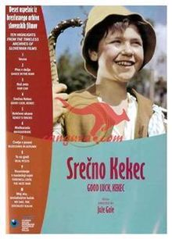
- triada
Srečno Kekec
https://www.dailymotion.com/video/x2comhz

- triada
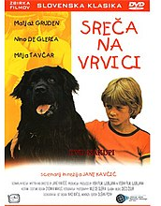
Sreča na vrvici
https://www.dailymotion.com/video/x2kdcqv
Pastirci
https://www.dailymotion.com/video/x2fao02

- triada
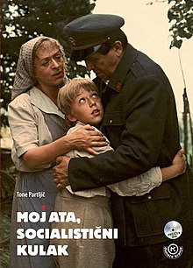
Moj ata socialistični kulak
https://www.dailymotion.com/video/x5kozr9
Gremo mi po svoje https://www.youtube.com/watch?v=0dVdMLMpHDE&fbclid=IwAR0vd6izte-Wk2lGa_P6TG2PyWl7dU7MxltC4PnKu7DJ8JIgD90tGvtUHpM
Gajin svet
https://www.youtube.com/watch?v=OWrXlSuFugg&fbclid=IwAR1IokwpojfqUoRIUZ8JLf-ER-un9ezRTudVBuTtnpVpvVI3Nlan8oP8qBA
Ne joči Peter
https://www.dailymotion.com/video/x2fand5

